Did you know these words in English? Watch them carefully for a moment.

 | ghost | 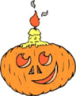 | jack o'lantern
 | mask | 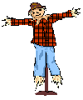 | scarecrow
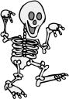 | skeleton | 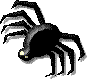 | Spider
 | sweet |  | vampire
 | bat | 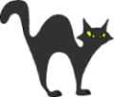 | cat
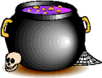 | cauldron | 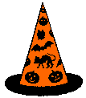 | hat
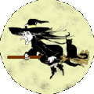 | witch | 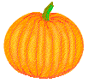 | pumpkin
1 Miaow! Miaow!  I always say  and with the witch  I always play. | 2 I wear in black  with a big hat  and a cat. | 3 Day or night  my bones  are white. | 4 I'm very small.  I've got eight legs.  I spin a web  and never fall.

